**A PROJECT REPORT ON**

**“ROBOTIC VEHICLE WITH SPEECH RECOGNITION”**

# Submitted

**In partial Fulfillment of the requirements For the Degree Of**

**BACHELOR OF COMPUTER APPLICATIONS**

# By

**ROHIT BHANDARI**

**Under the supervision of Ms. POONAM VERMA**

**(Asst. Professor, GEHU)**



**To the Department of Computer Application Of**

**GRAPHIC ERA HILL UNIVERSITY DEHRADUN**

**(2016-2019)**

**CERTIFICATE**

I hereby declare that the work which is being presented in the project entitled, **“ROBOTIC VEHICLE WITH SPEECH RECOGNITION”** has been carried out by **ROHIT BHANDRI** for the partial fulfilment of the requirements for the award of the **BCA**, submitted in the department of computer application, **GRAPHIC ERA HILL**

**UNIVERSITY** is an authentic record of our own **Ms. Poonam Verma**, Project Coordinator. I further declare that the matter embodied in this project has not been submitted by us for the award of any other degree.

## PROJECT INCHARGE

**MS .POONAM VERMA**

**ACKNOWLEDGEMENT**

We take this precious opportunity to express my gratitude toward **“ROBOTIC VEHICLE WITH SPEECH RECOGNITION”** to grant is permission for undergoing the project. Without its willingness to permit this project would not have been succeed.

First of all, we would like to thanks all those people who helped us directly or indirectly to complete our project whenever we found our self in problems. Our all faculties encourages us and due to their kindness and helpful nature and help we get very much confidence to complete this project.

We are deeply inherited who devoted his precious time in giving us the information about the various aspects and gave support and guidance at every point of time. We are really thankful to

Their kind and supportive nature. His/Her inspiring nature has always made me work

easy.

Last but not least, we would like to express our gratitude to **Ms. Poonam Verma**

who directly or indirectly helped in our project.

**ABSTRACT**

In this proposal we will mention about our capstone project. Our capstone project is voice controlled car. In this project our aim is to control a car with our speech. We are going to use a computer to take our voice and simply process it with MATLAB and send commends to the wireless device which we will make, and with this comments we are going to control a car. We want to make a simple speech recognition program with MATLAB and a wireless device which took commands from MATLAB and sent to a car. We want to understand how to make speech recognition program and sending this programs result to a car wirelessly and real time.

**TABLE OF CONTENTS**

1. Title Page 1
2. Certificate 2
3. Acknowledgment 3
4. Abstract 4
5. INTRODUCTION 1
   1. Voice and Speech, Voice Input and Speech Recognition 1
   2. Microcontroller Devices 2
   3. Computer to Microcontroller Communication 2
   4. Max232 to Microprocessor Wireless Data Transmission 3
   5. Radio Frequency and Frequency Modulation 3
   6. Controlling Multiple Motor Using By Microprocessors 4
   7. Arduino Device 4
   8. Computer to Arduino Communication 4
   9. Bluetooth communication 5
6. Technical Content 6
   1. Identification and Significance of Problem 6
      1. Speech Recognition Applications Benefits for World 6
      2. Microcontrollers Benefits 6
      3. Computer Serial Data Transfer Benefits 7
      4. MAX232’s Benefits 7
      5. Wireless Communication’s Benefits 7
      6. Radio Frequency system’s Benefits 8
      7. Using Motors’ Benefits 8

2.1.7 Using Arduino Benefits 9

2.1.7 Bluetooth’s Benefits 9

* 1. Technical Background 10
  2. Technical Objectives 35
     1. Speech Recognition 35
     2. Wireless Communication and Serial Communication with Computer… 36
  3. Work Plan 37
     1. Speech Recognizing Working Plan 37
     2. Computer to Microprocessor Connection Working Plan 38
     3. Wireless Communication Over Microprocessors Working Plan 38
     4. DC Motor Controlling Plan 37
     5. Arduino and Adafruit Motor Controlling Plan 38
     6. Bluetooth Communication Plan 38

2.5 Related Work 40

1. FACALITES AND EQUIPMENT 41

REFERENCES 43

# LIST OF FIGURE

Figure 1.1: Design level for Voice controlled car project 5

Figure2.1 (a) standard condenser microphone circuit

1. electret condenser microphone. 11

Figure 2.2 electret microphone cartridge. 11

Figure 2.3: two input canceling approach 12

Figure 2.4: Equation for two input canceling 13

Figure 2.5: two input canceling approach 13

Figure 2.6: Mel cepstral analysis synthesis system 14

Figure 2.7.: Equation of Markov chain 14

Figure 2.8: a pattern recognition paradigm based on Hidden Markov Models 15

Figure 2.9: spectral decomposition approach 15

Figure 2.10:Equation of approximate formula to compute the Mels 16

Figure 2.11: Workflow for the MFCC based speech classification. 16

Figure 2.12: Aurora-3 task results madden by Microsoft Research Center. 17

Figure 2.13: Application to hardware Microsoft Windows operating system. 18

Figure 2.14: A close up shot of an Intel microprocessor, released in 1992.. 21

Figure 2.15: magnetic field and coil inside it rotates DC motor. 22

Figure 2.16: Lorentz forges law 23

Figure 2.17: dc motors inside’s schematic. 24

Figure 2.18: MAX232 Pin Configuration and Typical Operating Circuit diagram. 25

Figure 2.19: indicates fist wireless device photo phone demonstration. 26

Figure 2.20: Frequency modulation. 27

Figure 2.21: fundamentals for digital modulation characteristics. 27

Figure 2.22: PSK modulation system characteristics. 28

Figure 2.23: FSK modulation system characteristics. 28

Figure 2.24: FSK modulation system characteristics. 29

Figure 2.25: Arduino UNO board and its USB connection cable. 31

Figure 2.26 Arduino software an empty page screen shoot. 32

Figure 2.27: Adafruit’s motor shield circuit. 33

Figure 2.28: Bluetooth master and slave network. 34

Figure 2.29: Microsoft visual studio start page screen shoot. 35

Figure 2.30: PIC16F877A PIC pin diagrams. 36

Figure 2.31. Final pictures of the project 41

# INTRODUCTION

This project is about voice controlled car. Due to making this project speech recognizing fundamental and other importing issue is sending speech recognizing results to car via using wireless system.Speech recognizing also known as "automatic speech recognition (ASR)", "computer speech recognition", "speech to text (STT)". This project has several parts like voice input and recognizing, computer to microprocessor communication, microprocessor to microprocessor wireless data transmission (wireless remote controller), controlling multiple motor using by microprocessors.

## Voice and Speech, Voice Input and Speech Recognition

Voice is a sound which produced by humans or animals. Voice uses airflow that comes from lungs. Air makes pressure over vocal folds and these vocal folds vibrate. Normally speech produces as whisper in our throat by using neck, chest, head and abdomen this whisper becomes our speech. Our speech is unique for every people and also it helps other people to understand each other’s personality, mood and most importantly it helps people to communicate. Sounds are using mechanical waves for traveling around gases, liquids and solids. Mechanical waves transport their energy to one medium to another medium while using vibration. Due to take voice microphone is required. Microphone is a hardware which can convert analog input to a digital output. Digital data can be understand, modify and store by computers. Computers can recognize speech by using some complex algorithms and good dictionaries for these algorithms. Most of recognition programs use Hidden Markov Model (HMM) and Mel-frequency cepstral coefficients (MFCC) and frequency specral decomposion technique to use both of those algorithms. WE have used Microsoft Visual Basic for making speech recognition it can access Microsoft’s speech recognition tool while using framework, .NET and C# programming language. First Microsoft speech recognition tool has been introduced for Microsoft vista at 2006 and this toll uses Microsoft SAPI (Speech Application Programming Interface) interface packed and this packed includes Microsoft speech recognizer program for windows.

## Microcontroller Devices

Microcontroller is an integrated chip and it’s also called as embedded system which includes CPU, RAM, ROM, I/O parts. Microcontrollers is like small computers but they are much simpler than the todays computers they can do simple specific tasks to control system. The advantage of the Microcontroller is, it is far cheaper than a complex controller. Microcontroller generally uses metal oxide semiconductor (CMOS) technology on the manufacturing process developers used less power and less resources. Generally microcontrollers’ uses 5V DC voltage to work but this can be change by the different microcontrollers. In this project WE used microcontroller to make the car and while doing this We have used microchip’s PIC 16F877A microcontroller. PIC 16F877A microcontroller has forty pin four of them for the feeding, two of them for oscillator. Oscillator is a simply clock with constant frequency in the project WE have tried two different oscillator one of them 4 Hz and the other were 8 Hz. For the programming PIC microcontroller there are many option PIC microcontroller does not interested complier or editor too much as long as code and configuration setting were true and hex file correctly complied. In our project WE used microchip’s MicroC editor and complier program. Codding is not so hard on these microcontrollers the hard part is setting true configuration settings for right hardware. To add hex files to the microcontroller there are many ways we can use debugger or an installer board can fix this problem but for different platforms we need to change our installer software too.

We used different ways first WE used boards that school gave to us but WE could not have successfully results from them on the capstone one….

## Computer to Microcontroller Communication

Computers have many output protocols and hardware like USB, HDMI, SD, Ethernet and VGA. Visual basic has its own connection tools for this kind of connection. Today most of applications about computer to microcontroller use VGA, USB or similar connections for PC (Personal Computer) to microcontroller or similar applications. Serial ports and VGAs use RS232 protocols to send serial information. PIC (Peripheral Interface Controller) has also its own connection protocols and libraries for this kind of communications. It has UART library which helps PIC to communicate with each other or other devices like PC.

## Max232 to Microprocessor Wireless Data Transmission

Wireless systems are very common in these days and WE want to make wireless a simple wireless receiver and transmitter to communicate speech recognition program with car. PIC is a microcontroller producing by Microchip Company and their microchips have a lot of application areas like wireless so WE want to make a wireless receiver and transmitter that use PIC microcontrollers. Due to this kind of communication applications PIC microcontrollers generally uses UART library to communicate with each other. After establish code there is necessary to have receiver and transmitter components. For the transmitter part WE have to take values from our computer to doing this WE have to use some component. MAX232 is a very useful solution for this connection; MAX232 uses RS232 serial port cable to communicate with PIC microcontroller. MAX232 converts computers signals coming from RS232 cable and sends converted signals to the PIC microcontroller. MAX232 component uses 5V DC as a input but it can also stands approximately 7.5V DC.

## Radio Frequency and Frequency Modulation

Radio Frequency is using very frequently in our live, it is on the air and because of radio frequency people can listen radio frequencies, watch television, communicate from long distance without cable and with using this people also can do various things. Radio frequency is a kind of electrical current that have some certain properties that allow it to broadcast with using an antenna. If an AC current generates an electromagnetic field or a wave at a frequency that is necessary to broadcast, then we can say this AC current is Radio frequency. These frequencies are not visible for human eyes these are infrared side of visible light. We have used an RF receiver and a RF transmitter WE have connected our RF transmitter to the MAX232 circuit to send values MAX232 converted comments to the RF receiver we connected PIC 16F877A circuit. Our RF components is very simply ones the only uses 433 MHz frequency and this is approximately equal to the 433 cycles per second. Importing thing is when we use these components our receiver and transmitter frequency should be equal if it is not than they cannot communicate with each other. There are two important radio modulation technique exist today they are Frequency Modulation (FM) and Amplitude Modulation (AM).

## Controlling Multiple Motor Using By Microprocessors

By using motor drivers PIC microcontrollers can control DC, AC or any other kind of motors. Drivers protect PIC and motor from burning problem. Motor drivers also provide bigger voltage for motors because PIC microcontrollers use five volt input and output. There are some drivers can help microcontroller to control two different motor those component called as dual h-bridge motor driver. WE have used a motor driver that can control two different motors but instead using one to control two motor we used two of them because these drivers get hot so quickly to avoid this situation I could use a metal panel but we had two motor drivers and we wanted to use both of them in our project that is why we used two motor controller in our car circuit.

## Arduino Device

Arduino is open source electronic prototyping platform based on flexible to use easy to use hardware and software tool. Arduino has a microcontroller inside its hardware it is different than WE used on the microcontroller part of the project part. Arduino uses ATmega series there is many type of Arduino exist today most popular ones are Arduino MEGA, Arduino UNO and many other type. We have used Arduino UNO it uses ATmega328 series of microcontroller has 28 ports inside it. Software of Arduino is very easy to use it does not requires too much configuration one you choose your dictionaries and wrote your code Arduino takes care of all other configuration settings and makes things much more easier. To installing code to Arduino is also very easy after code verified its complier than user just need to connect its cable to the PC than Arduino’s software finds its hardware and when user installs code to the hardware it is still easy to debug Arduino without using different hardware or software. If user defines serial communication with PC then user can check what Arduino does when it’s working.

## Computer to Arduino Communication

To communicate with Arduino we first need to install its free software on the internet and install. The software is very easy to use and install it creates just one .uno files on the

|  |  |  |
| --- | --- | --- |
| microprocessors these files are making user confuse because of there are many different file generating. After installing Arduino is ready to usage including dictionaries using dictionaries is very easy on the Arduino and Arduino does not requires any configuration setting when programming these setting madden by program itself on the background. User can use USB cable to connect Arduino and after that user can install his code to Arduino far more easily and quickly than microcontroller.  **1.9. Bluetooth communication**  Bluetooth is one of the popular devices to communicate in short range it is using on computers, cell phones, head phones and many other devices. Bluetooth devices use 2.4 to  2.5 GHz frequency to communicate with each other’s. Bluetooth standardized as IEEE  802.15.1 but then it changed that 802.15.1 Bluetooth’s range is 2400–2483.5 MHz approximately. Bluetooth devices generally use frequency-hopping spread spectrum communication technique to communicate each other. It can have approximately 40 channels and signals hops 1600 hop per second. Bluetooth devices firstly search each other once one find other it shows device to its user if user decides to communicate with device he paired those two devices and starts communication.  Hardware designs, Hardware connections, Hardware integrations,  Communication tools,  Input voice,  Hardware errors  Computer programs,  Coding languages, Communication protocols, | |  |
| Coding errors Speech recognizer  Design 1.1: Design level for Voice controlled car project | Output data,  Serial communication system, Wireless communication syste Motor controlling system, Voice controlling,  Simple Cars, | m, |
| 5 | |  |

# Technical Content

## Identification and Significance of Problem

## Speech Recognition Applications Benefits for World

There is too many control devices in the environment like car steering wheel, computer keyboards, elevator buttons, etc. But all these processes can be made easily with human speech. Speech recognition programs can be also using by government or a company to communicate or guide to people who need some official paper or other applications from these companies. People can speak with speech recognition programs and find their way, buying something things or services, access data from data base, write their documents, writing text messages, making internet search, controlling wheelchair for paralyzed people etc. all those services are available with touch system but with very good speech recognizing system this kind of services will be using much more easily and make for user search efficient and faster. With improvements in artificial intelligent systems speech recognizing systems will be more importing and its using area will be increased faster.

## Microcontrollers Benefits

Microcontrollers using in many different applications by now on the first computer developers used microcontrollers and in the basic daily life many device we see controlling by microcontrollers. Microcontrollers do specific jobs on the circuit they used in battery charges, printers, scanners, stereo systems, etc. there some different processors for embedded systems there are general purpose processors like intel and AMD, Micro- controller processors like PIC microchip and 8051, special processors like TMS320 series DSP and finally application specific instruction processors. In our case microcontroller processors have four main features one of them is on chip peripherals like timers, analog to digital converters, secondly on chip program and data memories, third direct programmer access to chips pins, and fourth is specialized instructions for bit manipulation and lower level operations. And their applications are reading sensor data, setting actuators, dealing with bits little amount of data, they can be using on the disk drive, digital camera, washing

machine or etc. microprocessor works with using hex files.

## Computer Serial Data Transfer Benefits

Today computers have varied usage area in the engineering society so connecting devices to computer and other similar devices is fundamental. Computers have many applications inside it and these applications can be easily changing by using keyboard and good algorithm so connecting devices to the computer provides user that improve his device and obtain new skills from them. Connecting computer property also provides user that control his equipment easily and enable user to check that device frequently. Another importance using area for serial port is data transfer, PC to SD, Flash, external memory, etc. people also using this communication for taking information or give information to their phones, cameras, tablets and other similar devices.

## MAX232’s Benefits

Max232 component is very useful for the projects like mine, PIC microcontroller need to understand what computer commands but in this part communication between them is pretty complicated to make this job We have used this component. It simply converts computer data to biliary numbers which our PIC can easily understands and process.

## Wireless Communication’s Benefits

Wireless systems is very importing in these days, these systems removes cables around and gives its users to ability connect internet and wireless networks for many different applications. With smart phones wireless technology using area increased these systems are very importing for community. Government use this wireless networks in the public areas like Istanbul metropolitan municipality use wireless technology to get location of their busses and via mobile applications they share this information with the Istanbul citizens. In these days communicating is very importing issue and with improvements in the

wireless technology systems communicating is being much easier and efficient. On the project we have used two type of wireless device these devices are radio frequency and Bluetooth.

## Radio Frequency system’s Benefits

Radio frequency systems is essential for these day it used by many device around us. With using Frequency Modulation technique we can listen sound in the range any radio station and it is also common to use this modulation people communicate each other over long distances. Radio is one of the important events on the history it is like new era on the communication system, before radio being frequently used people used other techniques but these techniques were slow and not guaranty to carry. Today we use cell phones and those phones uses radio frequencies with using different modulation techniques. Because of radio frequency we can watch television, all we need is a simple antenna then we can listen and see pictures on the screen. Satellites also use this frequency to communicate with word and sending their broadcast to the people. On the emergency situations these radio frequencies are using to communicate between helper groups to save people or help them in these case police, hospitals, and similar companies uses those frequencies to communicate.

## Using Motors’ Benefits

Motors are using in many industrial and daily application like cars, elevators, etc. to make our live more easy. Without of motors people could make many hard jobs with their body power and this is not so efficient for today’s industry. Motors are very popular and controlling them is very importing issue engineers and scientists still try to control motors more efficient. With efficient motor control industrial technology could be improve much faster and this affects other areas either. There is much kind of motors in the industrial area because their applications vary due to application it used.

## 2.1.7 Using Arduino Benefits

Arduino is open source electronic prototyping platform based on flexible to use easy to use hardware and software tool. Arduino has a microcontroller inside this microcontroller control its own hardware and while using given pins it help user to do different kind of applications. Today many artists, designers, engineers and hobbyists, who interested in creating interactive objects or environments on their systems, use this prototype to create new projects. Arduino has its own software it can be freely downloadable on the internet and it is just one file easily installing and there is no necessary configuration requires. Arduinos dictionaries are fairly easy to use, they have its own examples on the software and these examples are very tutoring.

## 2.1.7 Bluetooth’s Benefits

Connecting things is getting very complex thing because there is too many cables and too many port. With Bluetooth technology this problem could be solving and people could connect their devices more easily, more beautify. The main idea of this invention is cable-free computer connections, which means real freedom for working environment regardless wire availability and device restriction. This Bluetooth technology allows portable computers, notebooks, mobile phones, personal digital assistant and other helpful materials to use short range, low power radio technology to connect to each other very easily. Bluetooth is using 2.4 to 2.5 GHz frequency spectrum to communicate. While Bluetooth communication with other Bluetooth device its signals hops between channels and frequencies. It can communicate in the short range but its usage areas very varying, it can be used to data transmission between two devices like computer to computer, computer to cell phone, cell phone to computer, cell phone to cell phone. Bluetooth also using to head phones to connect musical device, computer or cell phone wirelessly, Bluetooth communication is pretty secure it hops between frequencies so jammers and similar devices getting hard time to restrict its communication. Bluetooth also can easily choose device that it will send its data, firstly Bluetooth device search device near it and second it ask user should WE get paired with this device to connect it securely and if user permits they starts to their

communications.

## Technical Background

Voice is a sound generating from humans or animals while producing it people using their lung, vocal fold, muscles. Voice producing has two different steps, one of them is humans create a voice using airflow over their lungs and this airflow vibrates their vocal fold and this vibration called voice. Voice is changes by genre for humans for women it is around 180 to 220 Hz and for men it is founded 110 Hz. High voice’s frequency is bigger but for low voices amplitude is greater.

Due to figure 1; first image in figure one shows closed position for vocal folds. Second and third pictures show airflow pressure over closed vocal folds. Fourth and fifth pictures indicate that air passed vocal folds and opened it this starts the voice. Sixth to tenth pictures about air’s movements cause Bernoulli Effect on the vocal folds. Bernoulli Effect helps vocal folds to close and when vocal folds closed no air passes through it and voice finish.

Speech is generating by humans brain with their thoughts. Words that comes our thoughts, finding by brain and brain generates a mechanical sound pattern and this mechanical pattern will be implemented by human body. Human body produces speech by using brain and excellent coordinated muscles actions in the head, neck, chest, and abdomen. During one second speech, human body requires to use forty thousand of neuromuscular events

After speech created in our body it travels through air or other mediums which let it pass. Sound waves travel by using their energy to make vibration or collides movement and while doing this it comes to receiver. Today some specific devices using to receive sound waves one of the common devices is microphone. Microphone converts analog input to digital output.

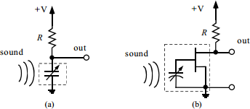

Figure2.1 (a)standard condenser microphone circuit (b)electret condenser microphone.

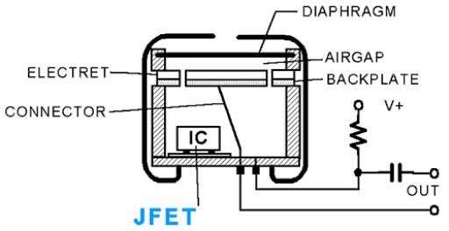Incoming sound waves comes microphone and this makes a mechanical deflection of the cone and voice coin. Microphone’s coil is moving around the permanent magnets and this creates a time varying current. Condenser microphones use electrostatic forces instead of magnetic induction. Condensers are a capacitor type and incoming sound waves’ vibration changes its capacitance.

Figure 2.2 electret microphone cartridge.

Due to implement applications with speech computers and other devices should detect and record voices. There are two type of recording option these are digital and analog. Most of devices records analog voices and after that they convert analog voice to digital voice if this is necessary. Analog signal is an electrical shape of a sound's vibration waveform, or variations in pressure devices like microphone transmits these vibrations of its

diaphragm to an electrical wave. This electrical wave goes to computer sound card or other audio devices. Analog audio should be converting to digital signal before recording it to the memory. Converter takes extremely much "snapshots" for detecting changes in electric wave patterns (between 16,000 and 96,000 per second) and make up outputs one code that allows a computer or other devices to use something similar data to the original sound pressures. With taking much more snapshots that one converter takes per second, digital copy will be more accurate

Speech recognizing systems allows computers to convert speech signals to text data. Speech recognizing can be madden by many devices one of the device is computers, computer and other speech recognizing devices uses algorithms to clear speech and recognize it. With out of appropriate filter Speech cannot be recognized by computer. Filters can clean speeches from noise, distortion, human articulation effects to make speech useful for recognizing algorithms there are also signal enhancement method could be use due to better recognizing.

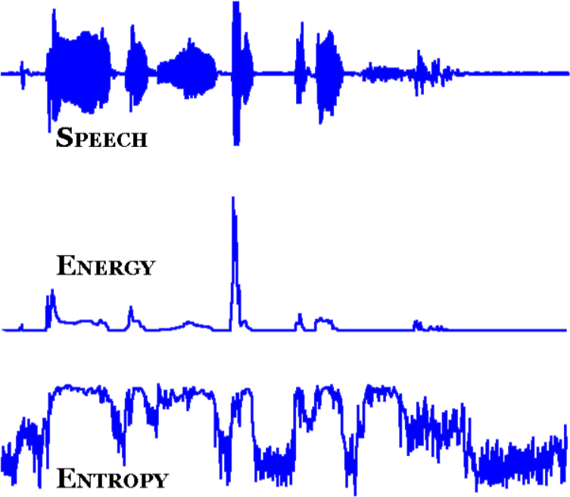Due to making a study for speech signals noise is one of the basic and important problem. Noises make difficult speech recognition for computers and other devices which interested with signals. Due to making a study for speech signals noise is one of the basic and important problem.

Figure 2.3: two input canceling approach

Noises make difficult speech recognition for computers and other devices which interested with signals. With using two input cancelling approach technique recognition errors could be reduce by about 75% (40% to 10%) it is depends speaker digit recognition task .Two input cancelling approach’s equation has showed in equation 2.4.

𝑑 (|𝑍|2 , 𝜎2

+ 𝜆) =

2𝜋 [ 𝑍|(𝑤)|2

− 𝑙𝑛 𝑍|(𝑤)|2

− 1] 𝑑𝑤

|𝐴|2

∫0 𝜎2 +𝜆

|𝐴(𝑒𝑗𝑤)|2

𝜎2 +𝜆

|𝐴(𝑒𝑗𝑤)|2

2𝜋

Figure 2.4: Equation for two input canceling

There is another noise reduction system cepstral algorithm can also be a solution for this problem. Ceptral analysis is a speech model based on inverse Fourier transform of the logarithm of the Fourier transform module. Equation 2.5 shows cepstrum of signal algorithm

𝑐𝑒𝑝𝑠𝑡𝑟𝑢𝑚 𝑜𝑓 𝑠𝑖𝑔𝑛𝑎𝑙 = 𝐹{ 𝑙𝑜𝑔 [𝐹−1(𝑠𝑖𝑔𝑛𝑎𝑙) + 𝑗 · 2𝜋 · 𝑚]}

Figure 2.5: two input canceling approach

With using cepstral algorithm, Mel frequency scale is much appropriate rather than linear frequency scale because of some old studies have shown that human sounds of the frequency content, either for pure tones or for speech signals, does not follow a linear scale. Figure 2.6 shows Mel cepstral analysis synthesis system.

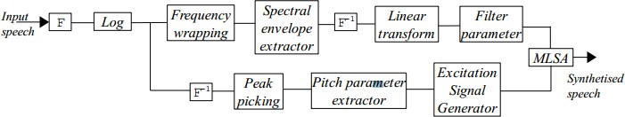

Figure 2.6: Mel cepstral analysis synthesis system

HMM and MFCC approaches are another speech recognition approaches that using in the speech recognition applications. Those two speech recognizing techniques can be gathering by using frequency spectral decomposing technique.

HMM is also referred as Markov sources or probabilistic functions of Markov chains. HMM assumes that speech signal can be characterized as a parametric random process these parameters can be estimated in precise, well-defined manner. HMM method provides a natural and very reliable method for speech recognizing. First order Markov chain has shown in equation 2.7. This equation’s right-hand side is should be considering because it is independent of time.

𝑃[𝑞𝑡 = 𝑗|(𝑞𝑡−1 = 𝑖 , 𝑞𝑡−2 = 𝑘, … )] = 𝑃[𝑞𝑡 = 𝑗|𝑞𝑡−1 = 𝑖]

Figure 2.7.: Equation of Markov chain

Hidden Markov Model determines likelihoods of acoustic observations. HMM’s search space can be making or updating via using a finite grammar or statistical language model search space also include determined acoustic model, grammar and language model. Dictionary grammar defines preferred state automation differences, probabilities and changes between words. Language models generated by older trainees and their statistical frequency measurements of the word which interested shows researcher differences and changes between each old words. Figure 2.8 indicates basically pattern recognition paradıgm based on based on HMM.

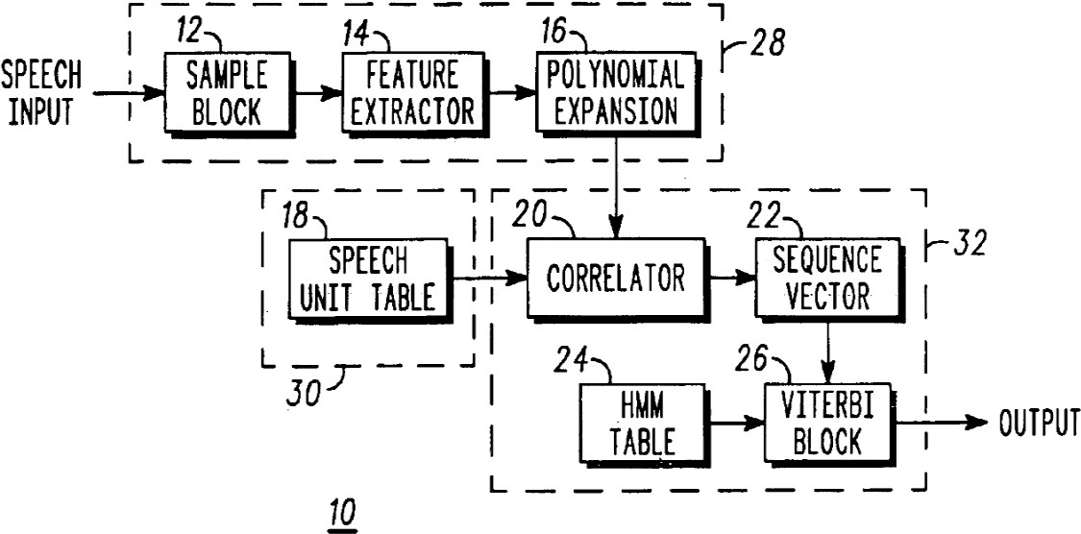

Figure 2.8: a pattern recognition paradigm based on Hidden Markov Models

MFC Mel-frequency Cepstrum is using for sound processing applications, it is indicates that short time power spectrum of a sound. MFC uses linear cosine transform of log power spectrum on a nonlinear Mel-scale of frequency. MFCC has coefficients which has using MFC. These coefficients derived from an audio clips cepstral representation which is nonlinear.

Cepstrum and Mel-frequency Cepstrum’s main difference is MFC because of MFC’s frequency bands equally spaced in the Mel scale and this provides much more closely approximates of the human auditory system’s response rather than linearly spaced frequency bands used in the normal Cepstrum. Figure 2.9 shows spectral decomposition approach and equation 2.10 indicates approximate formula to compute the mels f is frequency in hertz.

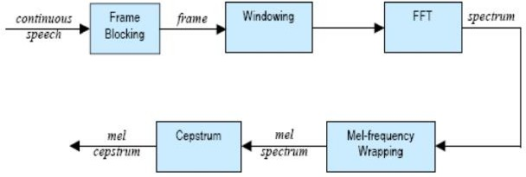

Figure 2.9: spectral decomposition approach

𝑚𝑒𝑙 (𝑓) = 2595 ∗ 𝑙𝑜𝑔10 (1 + 𝑓 / 700)

Figure 2.10:Equation of approximate formula to compute the Mels

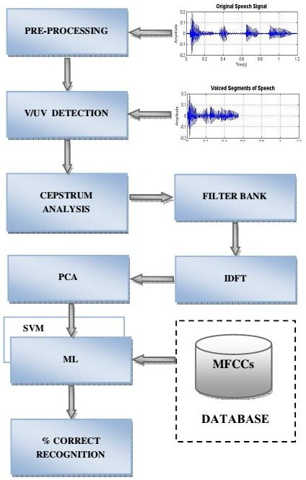Due to deriving MFCC’s implementer should first take Fourier transform of the signal and after Fourier he should make mapping for the power of the spectrum obtained from Mel scale by using triangular overlapping windows. Third step taking logarithm of Signal’s power at Mel frequencies after this step; if this is signal, it is necessary to use discrete cosine transform for the Mel log powers and finally MFCC amplitudes of the final spectrum. Figure 2.11 shows MFCC based speech classification.

Figure 2.11: Workflow for the MFCC based speech classification.

Today many of software and hardware developer use those algorithms and technique to make efficient speech recognizing. For example Microsoft uses minimum mean square error (MMSE) which is criterion of MFCC. Microsoft uses MMSE criterion to make environment robust speech recognition software. With using this algorithm they gain more instantaneous phase asynchrony between clean speech and mixing noise then using their old algorithm (E&M) algorithm. Due to standard Aurora-3 task demonstrates that reduction error 48% for ICSLP02, 26% for cepstral mean normalization CMN, 13% for conventional E&M log MMSE and even better results for MMSE on MFCC. Table 1, 2, 3 in the figure

2.12 shows results of Aurora -3 task.

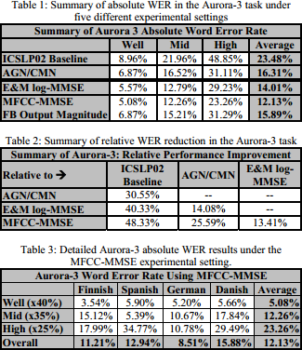

Figure 2.12: Aurora-3 task results madden by Microsoft Research Center.

Before start to explain how Microsoft Window’s speech recognizing program working, it is important to know how Microsoft Windows does works. Microsoft windows is an operating system which includes many software, derivers, configuration that manages computers hardware systems and manages their resources for its and users profits. Today

nearly all applications systems require an operating system to process on the computer or similar device. Most popular operating systems in the word are Microsoft windows, MAC and Linux open source operating systems like Ubuntu. Microsoft Windows uses IBM’s DOS (Disk Operating system), IBM generated this system to usage of the personal computers but after it gained graphical user interface (GUI) ability then it is start to being importing for Microsoft. DOS’s Kernel type is Monolithic its mean it is defines high level virtual interface over the computer or devices hardware system. Figure 2.13 shows application to hardware flow diagram.

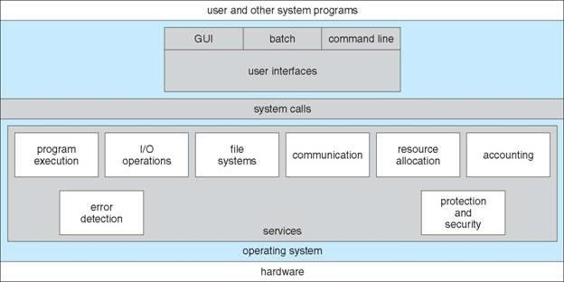

Figure 2.13: Application to hardware Microsoft Windows operating system.

Operating systems also provide communication between different systems like Arduino, microcontroller, internet, head phone, Bluetooth, etc. systems. The communication usually exchange information between other systems the information divided into packets by operating system and its also moved those packets to the receiver device or system. Computers do many process while its user does not notified these quests that are madden by operating systems. While operating systems does these quest, communicate and process data it also make errors and it detect errors also. Operating system also does protection and security quests it protects system resources and ensures it is secured. Security system requires user authentication and defends system to outsides attacks.

Microsoft also uses HMM model and other speech recognition algorithms to for

instance in the acoustic modelling Microsoft uses HMM(most common), segment models, super-segmental models, hidden dynamic models, Neural-Network HMMs, maximal entropy models and hidden conditional random fields, etc

Microsoft speech recognizing is very good application for making speech recognizing they uses and researches many algorithms and techniques to make this speech recognition application. In the early 1940 IBM and its partners tried to make an automatic speech recognizing tool and Microsoft’s speech recognizing tool began with this working. Microsoft firstly used its speech recognizing tool on the ease of access part. Now Microsoft speech recognizing toll is a part of Microsoft Windows operating system Microsoft is using it in the Microsoft office, Microsoft Agent, Microsoft Speech Server. Microsoft also allows software developer to write their own software’s while using windows speech recognizing tool on Microsoft’s supplied engines. Microsoft speech API is controlled by Microsoft applications and speech engines for recognition and synthesis. Microsoft names their speech recognizing tool to speech application programming interface or SAPI. They have five different versions SAPI 1, SAPI 2, SAPI 3, SAPI 4, SAPI 5 and its extensions.

SAPI 1 was came for Windows 95 and Windows NT 3.51 on year 1995 it was used for low level speech recognition and it was spotted by Microsoft’s control engines. SAPI 2 was very close to the SAPI 1 and it is come in the year 1996. It was more accurate than first one it is also used Microsoft’s control systems and engines. SAPI 3 released one year later the SAPI 2 released. Microsoft made their speech recognizer a supporter group and made discrete speech recognition and added some application for the speech recognizer they made. SAPI 4 was released on the 1998 and this version was included COM communication between devices. This version also gives users to chance to use this ability with using C++ programming language. Microsoft visual studio and visual basic are capable to use this language, C++ is considered as intermediate level language and it has both high and low level properties on itself. SAPI 4 has many applications on itself like Voice Command, Voice Dictation, Voice Talk, Voice Telephony, Direct Speech Recognition, Direct Text To Speech, and many other applications with using C++ language its application number varied. SAPI 5 is released on the 2000 and it is ability cooperate with lower versions of speech recognizer tools of Microsoft Windows created. When Microsoft published its speech recognizing they changed their design. Their new design is better than past versions it is cooperative with Windows system, drivers and its applications all this configurations are

managed and routed by using sapi.dll. this sapi made speech recognizing tool more engine independent so this speech recognizing tool not any more being requires specific engine to speech recognize and other applications. This new version of SAPI also used COM port and C++ language but with this version Microsoft added C language too and Microsoft supported its speech recognizing tool by adding it to visual basic and .NET applications. This version of SAPI included new skills and also supported and developed old ones these skills are shared recognizer, in-proc recognizer, grammar objects, voice object, audio interfaces, user lexicon object, object tokens. On the extensions of the SAPI 5 Microsoft added new languages like Jscript, C#, and similar languages, they supported their speech recognizer tools. They supported new languages on their speech analyzer dictionary and they made their grammar tools increased. They updated it to adapt new windows versions and their new update versions on the visual studio program Microsoft added new configuration, driver and made communication between speech recognition search engine.

Microprocessors are ultra-large-scale integrated electronic circuits that providing computational control. They process as the central processing unit (CPU) in the computers and they can also be used as microchips or chips. These microchips and chips have extremely tiny components with semiconductor material around them places inside it. Modern microprocessors have approximately ten million transistors for working as amplifiers, oscillators, switches and they also has resistors, diodes, capacitors and wires all those components packaged in the little microchip. Most of microprocessors has been created by using Von Neumann Architecture so they can make three different job these jobs are fetch, decode and execute. Fetch meaning is storing data which is binary format and this data can also be stored in a read only memory (ROM) or random access memory (RAM). Figure

2.14 indicates an Intel microprocessor close up shot.

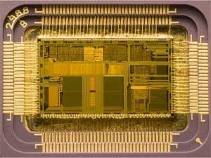

Figure 2.14: A close up shot of an Intel microprocessor, released in 1992..

Microprocessors has also Arithmetic Logic Unit (ALU) unit inside and this unit makes execution mission on the microprocessors. ALU has two main operations these operations are logic and arithmetic. Microprocessors also has clock component and this component generates clock signal with using this clock cycle microprocessor implements its applications.

Microprocessors are can communicate with LCD, other microcontrollers, computers and other similar electronic devices. Microcontrollers can take analog and digital inputs and while process it they can make new electronic applications. Microcontrollers requires an oscillator to count time so they can process their work correctly in time, embedded systems generally works with machine cycles and this cycles considered as their working timer. Microprocessors have different types and applications all of the applications should be depending on the timer if user of the embedded system should be consider its oscillator to get true process. Microprocessors should be minimal sized, minimal cost, increased reliability and maximize performance and they should be portable device, they could work with different networks and systems these microcontroller systems are very complex systems and their usage area it vary as written below. On the communication systems microcontrollers used very frequently this systems are telephone switches, routers and network bridges to communicate with different devices and different peoples. Microcontroller systems also used for motor controlling and other different applications it can drive a motor by itself but it would be harm microcontroller because this kind of control

does requires more protection to controller device instead of using microcontroller users should use a simple motor driver.

A motor deriver is a device group of devices that control a motor give a motor current to work control current to set its velocity and it also controls its torque. A motor controller protects motor and microcontrollers to sudden currents and overloads. These devices are easy to getting hot and it can break if user does not put a cooler metal component near it. There are many types of motor controllers some controllers are much more complex they can more accurately control the speed and the torque which connected to the motor these systems named as closed loop control system. Today using a motor controller has a many ways frequently used methods are automatic, manually or remotely controlled systems. Motor controllers are using with a power source like battery or power supply. This source should connect directly to the motors. Motor controllers are classified by their drive motors types these motors can be permanent magnet, servo, direct current, alternative current many other all those motor drives as different systems.

DC motors has a coil of wire and this wire rotates with respect to magnetic field around it. Split rings moves with effect of two different brushes magnetic load. Coil stand in the magnetic fields without moving this creates current over the coil and this current carrying wires creates torque over the coil itself. Coil’s position is vertical in the magnetic field and this vertical situation creates two opposite force over the coil, coil does not move with these forces because all forces are equal but these forces exert torque. Figure 2.15 shows magnetic field, coil and effect over the coil and magnetic field.

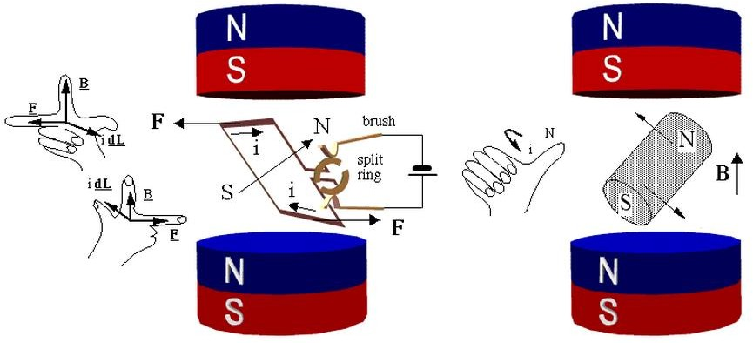

Figure 2.15: magnetic field and coil inside it rotates DC motor.

With using Lorentz force rule magnetic force affected coil can be found. Electromagnetic forces over the coil have a direction and this direction can be finding by using right hand rule. Equation 2.16 shows Lorentz forge law.

𝐹→ = 𝑞 ∗ 𝑣→ ∗ 𝐵→ = 𝑖 ∗ 𝑑𝐿→ ∗ 𝐵→

Figure 2.16: Lorentz forges law

Figure 2.15 is basic schematic of a motor but in the real electric motor case things get complicated. For example DC motors speeds depend dc current gave on it. Dc motors can be run both forward and backward depending current direction passes over it this direction can be changing by using H-bridges. DC motors has very high speed but they do not have that much torque. To gain much torque power, with using gears and transmissions motors speed power can be converting to torque. Other example is servo motors these motors has always same current inside it but size of the pulse determines direction of turning for typical servo motors large pulses means forward and smaller pulses mean backward. Servo also allows turning with an angle its typical movement is one or two degree for per pulse. Figure

2.17 shows a dc motors inside and above side of the figure is wound stator motor, below side permanent stators.

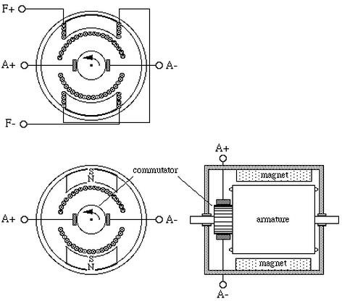

Figure 2.17: dc motors inside’s schematic.

MAX232 component is an integrated circuit, it first created by Maxim Integrated products. MAX232’s simple job was converting computers and similar devices RS232 cable communication signals to understandable signals for ıntegrated circuits like microprocessors and many other processors. MAX232 has dual receiver and driver on the inside and typically converts the RX, TX, CTS and RTS signals. MAX232 circuit also protects microprocessors from high voltages come from computer via RS232 cable. Computer send approximately 25 volt via using RS232 cable but this current is too much for the microprocessor so MAX232 simply took 15V DC and convert it to 5V dc voltage to do this it uses some on-chip charge pumps and some external capacitors. MAX232 component name could be changes due to its manufacturers but pin numbers and connection pins are nearly equal. RS232 has a logic output and input it process when it takes voltage from input, if input about +3V to +15V then it will give logic 0V for the (Rx) receiver and (Tx) transmitter output and for RTS/ CTS/ DTR/ DSR type of logic MAX232 gives 5V output. If MAX232 receives -3V to -15V for

the (Tx) transmitter and (Rx) receiver output circuit gives 5V and for the RTS/ CTS/ DTR/ DSR logic it gives 0V output.

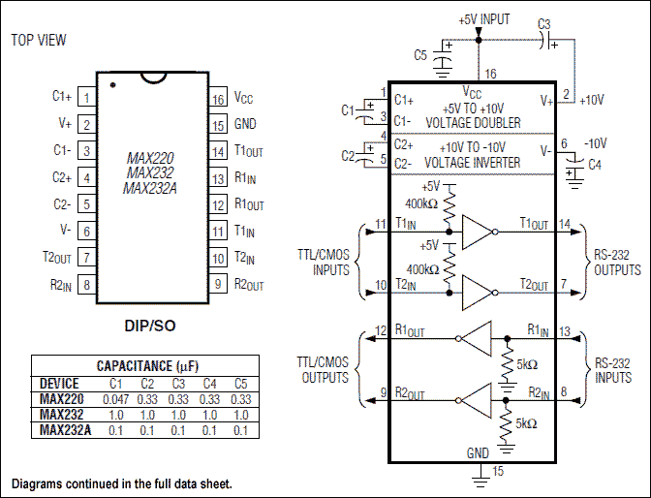

Figure 2.18: MAX232 Pin Configuration and Typical Operating Circuit diagram.

Wireless communication systems transmit data between to device or more than one device and while doing this it does not using wires. World’s first wireless telephone conversion had maddened in 1880 by Alexander Graham Bell who invented telephone. Alexander Graham Bell and Charles Sumner Tainter patented this new technology as photo phone that carries audio conventions wirelessly via using modulated light beams. In these days’ wireless technologies mostly using radio and less common method of using wireless technology is an electromagnetic wireless technology like light, sound, electric or magnetic fields. Figure 2.19 indicates fist wireless device photo phone demonstration.

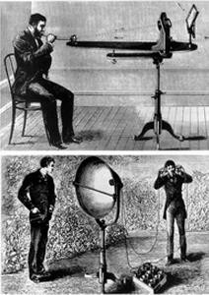

Figure 2.19: indicates fist wireless device photo phone demonstration.

In wireless systems sending data to one device to another there are many ways; one of them is radio frequency RF communication. To make a wireless data transmission RF is very efficient and common solution. Due to transmit data, transmitter needs to make modulation to carry data which we transmitted. This carrier usually is a cosine or sinus wave and this signal modulated with transmitter’s data after receiver receives this modulated signal it demodulates to use its data. Figure 2.20 contains three situation one of them, (a) indicate that sine wave modulation with frequency, (b) indicates resulting waveform’s spectrum, (c) spectrum after modulated continuous baseband signal has been shown.

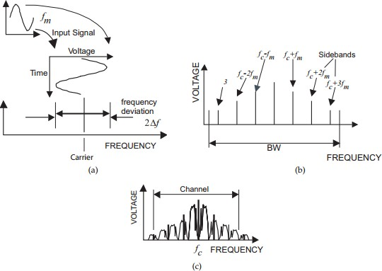

Figure 2.20: Frequency modulation.

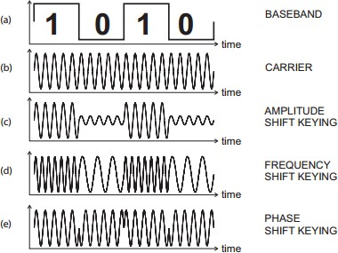Digital modulation is very old technique that used in many application with this modulation carrier was switched or keyed on and off to create some pulse shaped pulses. This modulation named as amplitude shit keying (ASK). Figure 2.21 shows fundamentals for digital modulation characteristics. During to design of this modulation technique developers tried minimize losing data in the message to make this system more useful carrier must have huge power.

Figure 2.21: fundamentals for digital modulation characteristics.

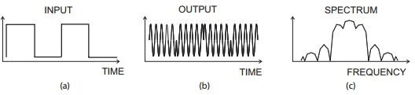Phase shifting keying (PSK) another way to modulation signal it is similar to frequency shifting keying (FSK) but for the PSK shifting in the phase and for the FSK shifting in the frequency. Figure 2.21 shows PSK characteristic and figure 2.22 indicates FSK characteristic.

Figure 2.22: PSK modulation system characteristics.

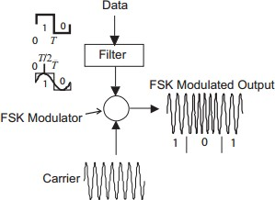For the figure 2.22 (a) representing bit streams these could be zeros and ones, (b) representing a modulated signal with using PSK, (c) represent modulated signal’s spectrum.

Figure 2.23: FSK modulation system characteristics.

Radio Frequency technique has been used by many wireless applications since its first invention. Radio Frequency is using very frequently in our live, it is on the air and because of radio frequency people can listen radio frequencies, watch television, communicate from long distance without cable and with using this people also can do various things. Radio frequency is a kind of electrical current that have some certain properties that allow it to broadcast with using an antenna. These frequencies are not visible for human eyes these are infrared side of visible light. If an AC current generates an electromagnetic field or a wave at a frequency that is necessary to broadcast, then we can say this AC current is Radio frequency. It is mechanical oscillation on the air and this oscillation carries some electrical

pusses with it these pulses considered by another machine and get meaning on their communication. Radio frequencies range can be vary about 3 kHz to300GHz, this corresponded frequency of radio waves and alternating current it carried. To carry pulses there is many modulation technique exist and using in this report main modulation technique used as (FM) frequency modulation. Frequency modulation is a wave with instantaneously frequency changing. Frequency modulation usually uses on FSK frequency –shifting keying technique this modulation and frequency usually used on the radios, radars and other similar devices. To understand FM signal to considering an modulating signal, figure 2.24 compares FM signals with modulating signal.

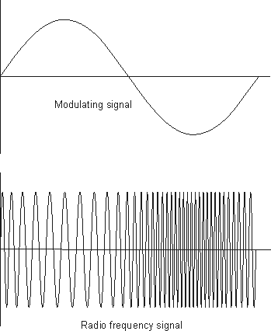

Figure 2.24: FSK modulation system characteristics.

Signals are modulated by using radio frequency carrier and then new radio frequency signal moves up and down in frequency as indicated figure 2.23. Signals move up and down is very important to communicate this movement known as the deviation and is normally quoted as the number of kilohertz deviation. For example the signal can have a deviation of

±3 kHz so carrier moves up and down by 3 kHz. Advantages of FM modulation are resilience to noise, easy to implementation with using low power on the transmitter components and receiver components, long distance when compared to the amplitude modulation which is used very frequently in daily life.

Arduino is open source electronic prototyping platform based on flexible to use easy to use hardware and software tool which includes a microprocessor. Arduino uses ATmega series microcontroller. Today there are many type of Arduino exist today most popular ones are Arduino MEGA, Arduino UNO and many other type. Arduino UNO uses ATmega328 series of microcontroller; it has 28 ports inside it. Arduino has 20 pins 14 of them are Digital I/O pins and 6 of them are PWM (analog) output. Arduino has 32k flash memory include itself and its clock speed 16Mhz.

Arduino’s specifications it is about 75x54x15 mm size and its weight 25 gram. Figure

2.24 shows a picture of Arduino UNO and USB connector cable with it. Arduino can be connecting computer with using USB cable. When user put computer its cable Arduino starts working uses power which took from computer and starts working. Arduino also permits users to debugging on their hardware and also software while computer connected to the computer if user defines serial communication with his board then he can easily see what Arduino does when it is working. Arduino allows fast transfer rates and there is no requirement for any drivers when using it and Arduino also have ability to connect some external hardware like Bluetooth, receiver, transmitter, mouse, keyboard, LCD screen and etc. when user connected external device all he needs to do indicate its dictionary on the code part and start codding and Arduino itself makes every changing, configurations, setting on its background engines.

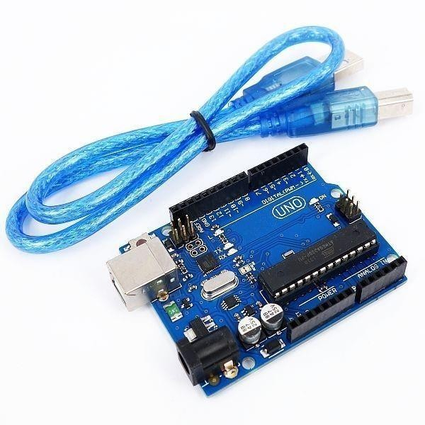

Figure 2.25: Arduino UNO board and its USB connection cable.

Arduino has it is own software and this software can be freely downloadable on the Arduinos own web side. This software of Arduino is very easy to use it does not requires too much configuration one you choose your dictionaries and wrote your code Arduino takes care of all other configuration settings and makes things much more easier. To installing code to Arduino is also very easy after code verified its complier than user just need to connect its cable to the PC than Arduino’s software finds its hardware and when user installs code to the hardware it is still easy to debug Arduino without using different hardware or software. If user defines serial communication with PC then user can check what Arduino does when it’s working. When software fist opened an empty space opening this pages name became today’s history and it called sketch_history and alphabetical count for number of new document. Arduinos option bar include five different menus these are file, edit, sketch, tools and help these menus help user to find user’s required applications. On the file menu examples are very tutoring for the beginners and they are also shows user how to use dictionaries on their applications. And second option bar includes verify, upload serial monitor, new, open, save functions. Figure 2.26 indicates an empty Arduino page on our computer.

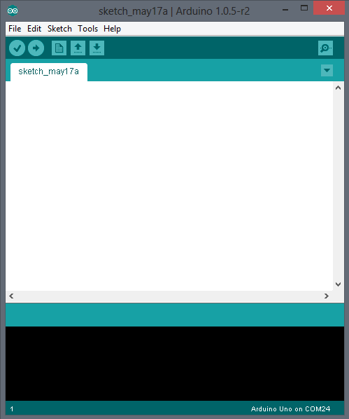

Figure 2.26 Arduino software an empty page screen shoot.

Arduino can be using with another hardware while installing and using its dictionary. In this project Arduino should control two different motor and to control these Adafruit motor shield has been used. This shield could control 4 different DC motor, 2 servo motor and 1 stepper motor. This shield provided 4H-Bridges on its L293D chipset and per bridge can stand and have self-shutdown opportunity for more than 0.6A or 1.2A peak. 4 directional DC motor have 8 bit speed control option this devices can stand hot and when something goes wrong they have protection diodes on their self. It also comes with its own dictionary to help users; users can directly write direction of rotation setting speed easily and manage motors torque. These shields also provide user to use six analog input pin of the Arduino so user could add another external hardware on his system. Figure 2.27 shows an Adafruit motor shield circuit.

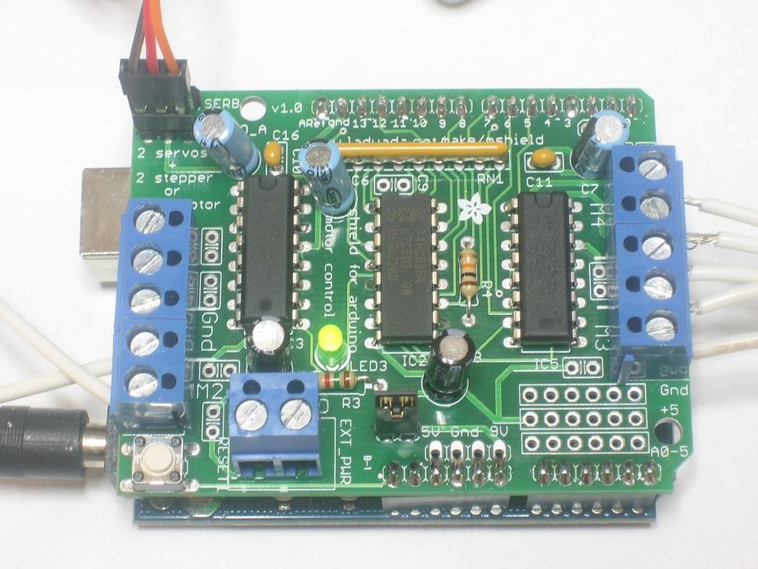

Figure 2.27: Adafruit’s motor shield circuit.

Bluetooth is one of the popular devices to communicate in short range it is using on computers, cell phones, head phones and many other devices. Bluetooth has been invented by Ericsson Company in the 1994. Bluetooth devices use 2.4 to 2.5 GHz frequency to communicate with each other’s. Bluetooth standardized as IEEE 802.15.1 but then it changed that 802.15.1 Bluetooth’s range is about 2400–2483.5 MHz approximately. Bluetooth devices generally use frequency-hopping spread spectrum communication technique to communicate each other. It can have approximately 40 channels and signals hops 1600 hop per second. Bluetooth devices firstly search each other once one find other it shows device to its user if user decides to communicate with device he paired those two devices and starts communication. Bluetooth has several versions such as Bluetooth 2.0, Bluetooth 2.1, Bluetooth 3.0 and Bluetooth 4.0 which is used today. Bluetooth is gained new technologies after first released some of them are Enhanced Data Rate (EDR), Alternate MAC/PHY, low energy protocols etc. has been added and used on the newer versions of Bluetooth devices. The protocols name can be varying in case of security, max speed, and bandwidth. Bluetooth’s data transfer rate is about 25mbps after new update 4.0 this data rate directly related on hopping frequency earlier versions old Bluetooth could hops 800 per

second. Connection with Bluetooth fairly easy as indicated before it is simply uses key matching process to connect each other and it requires and pair code between devices after it given devices connects each other. Security over Bluetooth is pretty good early versions of Bluetooth were encrypted to stop any attack coming from the outside and now they added key matching and pairing code. Bluetooth devices have a good search mechanism they can find other devices on the 30m range and they can connect with them. Bluetooth’s power requirement is very low but it is range is low and it is not so fast connection. Maximum range of Bluetooth is like 30m and it can connect with 7 different devices it is called piconet. Bluetooth can make slave and master connection with different devices on this network Master waits for its slaves when a slave connect its network and paired with it master send data to them and waits for answer, master also make those device synchronal and communicate between them. Figure 2.28 shows a Bluetooth slave and master connection.

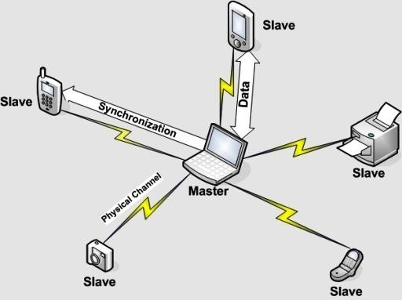

Figure 2.28: Bluetooth master and slave network.

## Technical Objectives

## Speech Recognition

Many software developers have been trying to make efficient speech recognizing since 1936.In 1939 Bell labs stopped working about it because John Pierce who works for Bell labs said this cannot be madden in those days because to make this an artificial intelligent is necessary. After 1970’s with using HMM approach, speech recognizing has been founded by Lenny Baum who is working for Princeton University and he shared this invent with advanced research project agency (ARPA) and IBM.

Microsoft fist approach for the speech recognizing is investing $45 million for partnership with Lernout & Hauspie. Lernout & Hauspie is a company that brought Kurzweil Company to have discrete word dictated level speech recognizing software. This partnership allowed Microsoft to use fist speech & voice recognition technology in their product and systems.

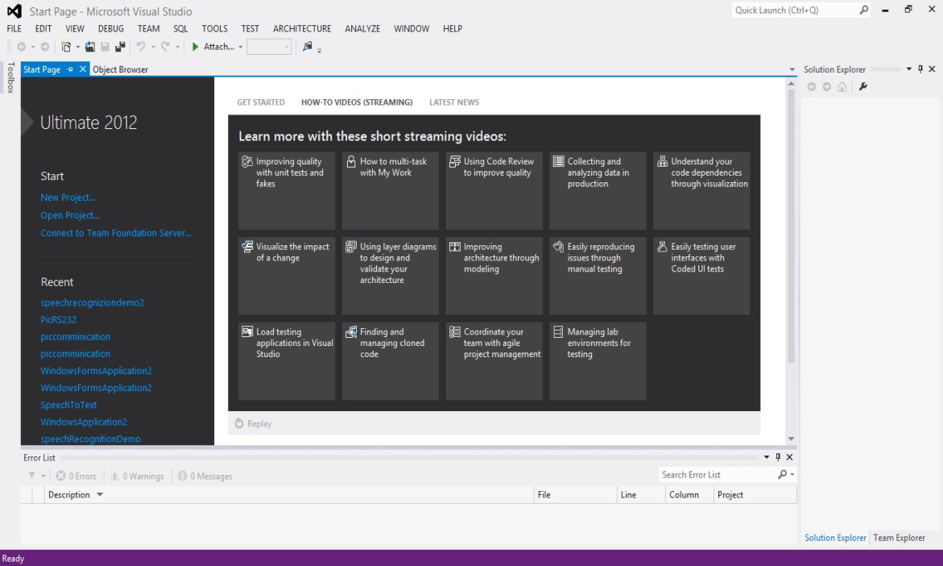

Figure 2.29: Microsoft visual studio start page screen shoot.

Microsoft created a speech platform in their software development kit (SDK) with using this platform user can make speech recognition and text to speech for multiple languages. Microsoft makes this platform useable for their user with using programs like Microsoft Visual Studio (VS) and any others with using .NET and framework protocols.

Microsoft Visual Studio first introduced by Microsoft in 1998. Microsoft Visual Studio using for software development tool, it also named as ıntegrated development environment (IDE) application. Microsoft VS has developing consoles, windows forms, graphical user interfaces (GUIs), web service and applications it is also supported by Microsoft windows, windows mobile, windows CE, .NET framework, NET compact framework and Microsoft Silverlight. VS .NET has intelligent sense code editor, code refactoring, debugger, build-in tools, form designer and this tools helps software developer to easier software development. For example, when software developer starts coding software on the VS, it shows possible functions, variables, events, etc. to help developer. Adding libraries and references very easy to call in the VS and after coding finished debugger function helps user to find errors and other possible application versions easily.

VS support C#, C++, visual basic (VB), F#, and many other software languages. C# is Microsoft’s implementation languages that usually uses .NET framework. To open a new application on the VS, software developers need to follow this path;

File > New > Project >Windows Application.

## Wireless Communication and Serial Communication with Computer

Peripheral Interface Controller (PIC) microprocessors are very common microprocessors. Their shape is different due to applications and version of them. PIC16F877A PIC pin diagrams can be seen in figure 2.30.

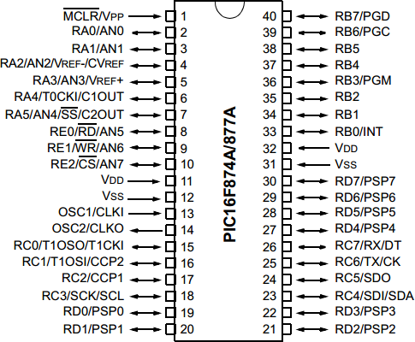

Figure 2.30: PIC16F877A PIC pin diagrams.

Due to programming this PIC microprocessor one of the best compiler is MicroC compiler developed by Microchip Company which also makes this PIC microprocessors. PIC microprocessors uses assembly and C programming languages but for programming them the easiest one C. C programing language is a basic level programming language founded for programming basic managing and controlling basic hardware. Screens shoot

## Work Plan

## Speech Recognizing Working Plan

Due to make speech recognition we first searched a good program and we came up with three solutions one of them were MATLAB second LABVIEW and last option was Microsoft Visual Studio. Fist we tried to MATLAB but we could not made it because it was much more complex than other options, again I had to use a dictionary like we did on the Visual studio but with using it we would have some problems to connecting hardware and communication tools. LABVIEW were a good program we installed it but we was not know it so we decided to use Microsoft Visual Studio. Microsoft Visio could use Microsoft speech search engine and this gives me better results than MATLAB and it was easier.

We searched Microsoft forums and visual studios example codes and wrote our speech recognizing code, we made it on the English language and specified with some words We wanted to use.

## Computer to Microprocessor Connection Working Plan

We have found some Visual Studio protocols to connecting program to a different hardware via using USB and RS232 interfaces. We could use this interfaces with MAX232 component this component protect Microprocessor and converts computers signals to the understandable form for the microcontroller. Our computer does not have a RS232 port so we brought a USB to RS232 cable and another cable to make this male cable female because our cables should connect with RS232’s pins. We made a simulation to control if it is working and saw it is working finely and I implemented the circuit we designed.

After hardware we wrote a serial communication protocol on the visual studio program, the code simply used serial communication to connect microprocessor. program should send output numbers to MAX232 correctly.

## Wireless Communication Over Microprocessors Working Plan

We brought receiver and transmitter components to communicate MAX232 with microcontroller. We connected MAX232 with the transmitter and we connected receiver with the microcontroller. Duty was communicate between them but that does not worked. We tried oscilloscope to understand error but we could not successfully connect them yet.

But on the software level we planned a addressing and security protocol we add two numbers before main control number came, this two numbers were protecting any other connection to our circuit and also protect noises provided mistakes. It is also provide a good addressing option to send data right device.

## DC Motor Controlling Plan

We used motor controller component on this circuit. We used our microcontroller to control motor driver We choose a motor driver and programmed our microprocessor with it. We also added an H bridge to this motor driver circuit, this H bridge provides more control and also it protect our motor and motor controller components. We tried to control four dc motor but we controlled two of them other two directly connected to the other motors pins to do same rotation.

## Arduino and Adafruit Motor Controlling Plan

We brought an Arduino board and a motor controller board for four motor but we just used two motor. We downloaded Arduino’s program on the internet and made some exercises to learn it and we also installed and learned how to use motor controlling with looking its exercises and its forums. We have learned how to connect Arduino with our computer and how to install program inside it. We have learned how to control motor how many motor can we control which pins are never used and which are used. We learned how to supply Arduino without of connecting computer.

## Bluetooth Communication Plan

We fist decided to communicate over something more accurate than RF communication than we came up with Bluetooth idea. Bluetooth is a short range communication technology, it is very accurate and works with less problem than RF. We brought Bluetooth device we firstly working something more useful than serial communication but Arduino did not support it and we used serial communication. we used

serial communication dictionary for this work and defined two analog ports to transmitter and receiver. We read HC-06 Bluetooth device’s data sheet and decided to give 3.3V to input but that was absolutely mistake for a long time we could not communicated with Arduino. We tried different techniques to solve problems but after a while we solved the problem. The problem was voltage; it was not enough we had to use 5V to communicate with Arduino. After solved problem we finished android part of the project.

* 1. Speech Recognizing Program.
  2. Making Speech Recognition.
  3. Correcting Results.
  4. Car Word Filter.
  5. Computer to microprocessor communication.
  6. Making a fine Working Design
  7. Understanding of USART Interface.
  8. Connecting PIC to the computer.
  9. Implementing Visual Studio Codes for Sending Results.
  10. Implementing MAX232 circuit
  11. Connection PIC to Visual Studio
  12. Wireless Communication.
  13. Making Fine Working Design
  14. Programming PIC
  15. Fixing Wireless Circuit’s Problems.
  16. Choose right pin to get data.
  17. DC Motor Controlling.
  18. Building H Bridge.
  19. Finding enough space on the circuit board
  20. Implementation motor control circuit
  21. Integrating Motor Circuits with Receiver Circuit.
  22. Arduino and Adafruit Car Circuit.
  23. Learning motor controlling with Adafruit motor controller shield.
  24. Learning Adafruit motor controller shield dictionary.
  25. Implementation Arduino circuit
  26. Bluetooth Communication.
  27. Learning HC-06 Bluetooth devices properties.
  28. Defining serial communication with HC-06 Bluetooth devices on Arduino.
  29. Sending data to C-06 Bluetooth device.
  30. Get data from computer

## Related Work

I have finished speech recognition program with using Microsoft Visual Studio but there is some parts still waiting to fix, these parts are;

* + 1. Make a car speech command filter due to make more efficient ordering to the car.
    2. Program sometimes gives wrong answers for the meaningless voices this error should be fixed.
    3. Speech recognizing tool should be connected to the PIC microprocessor with using visual studio.

Wireless system designs and codes works for simulations but implementations does not work so I will try to fix this error. Uart library is very importing to communication with PIC so I have to learn Uart module very well. Due to programming PIC I should introduce PIC to the computer.

PIC microprocessors usually has one receiver and transmitter port inside it but in wireless transmitter part of the project I have to find two receiver and transmitter ports or use another solutions like using different module for transmitter part or something familiar.

There is also motor implementing job new added to project so I should learn more things about DC and Servo motors and implementing them in the circuit. I have wrote wireless code and motor code but there is still some errors accrues about driving motors I have to fix this programs.

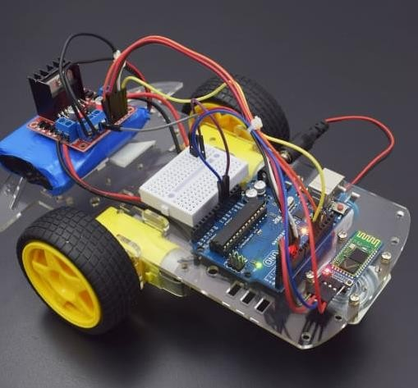

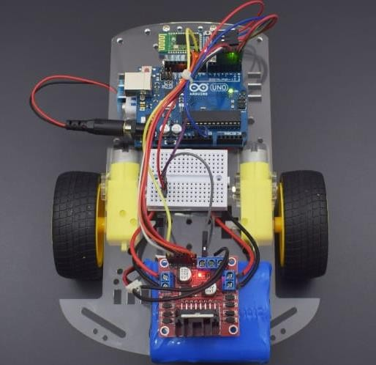

Figure 2.31. Final pictures of the project

# FACALITES AND EQUIPMENT

Computer programs;

Microsoft Visual Studio, MicroC for PIC, MicroProg Suite,

PROTEUS for circuit design and simulation, Office programs for reporting and documentations, BlueSoleil Bluetooth communication program, Arduino software to programming Arduino,

USB to RS232 cable drivers to open new COM port, Bluetooth drivers to open seven new COM port, USBburn111a5 to send codes to microcontroller, winPICPgm to PIC debugger,

Microsoft windows 8 for speech recognition engine,

Hardware;

Computer,

Microphone for taking input speech, Bluetooth device for PC,

Bluetooth device for Arduino, Arduino UNO,

Adafruit motor controller shield, USB to RS232 cable,

RS232 male to RS232 female cable; PIC microprocessor 16F877A, Transmitter 433MHz,

Receiver 433MHz, 2xAntenna, 2xBreadboards, Car,

Multimeter,

Batteries, 6xDC Motor,

Motor shield Adafruit, Oscilloscope,

3x 7805 regulator,

8x diode for H bridge, Punched board.

Components;

This part depend design of the wireless devices.

Resistors, Capacitors, Cables, Diodes,

And other components.

# REFERENCES

1. “Understanding How Voice is Produced” internet: <http://www.voiceproblem.org/anatomy/understanding.php>Dec. 19, 2013.
2. Dr. Joseph Picone, (1999, MAY, 15-17). Fundamentals of speech recognition: a short course. (1nd edition). [Online]. Available: <http://speech.tifr.res.in/tutorials/fundamentalOfASR_picone96.pdf>[OCTOBER 28, 2013]
3. B. York. ECE 2C Lab “Microphone Circuit” Department of Electrical and Computer Engineering. University of California, Santa Barbara. UC Santa Barbara, Santa Barbara. 2007.
4. Lawrence Rabier, Biing-Hwang Juang.(1993). Fundamentals of speech recognition. (1nd edition).[ On-line ] Available: [http://www.cin.ufpe.br/~lheva/voz,%20video%20e%20pds/Rabiner%20&%20Juang%20-](http://www.cin.ufpe.br/~lheva/voz%2C%20video%20e%20pds/Rabiner%20%26%20Juang%20-%20Fundamentals%20of%20Speech%20Recognition.pdf)

[%20Fundamentals%20of%20Speech%20Recognition.pdf](http://www.cin.ufpe.br/~lheva/voz%2C%20video%20e%20pds/Rabiner%20%26%20Juang%20-%20Fundamentals%20of%20Speech%20Recognition.pdf) [OCTOBER 28, 2013]

1. Kim Xu. Speech Detection in Noisy Environments. Internet: [http://www.cc.gatech.edu/~kweaver3/projects/MSU/csann.html,](http://www.cc.gatech.edu/~kweaver3/projects/MSU/csann.html) [ Nov. 6, 2013]
2. Cecilia CARUNCHO LLAGUNO (April 2008). cepstral analysis synthesis on the mel frequency scale, and an adaptative algorithm for it. 1(1), pp. 1-6. Available: [http://www2.spsc.tugraz.at/www-archive/AdvancedSignalProcessing/SS08- SpeechSynthesis/cepstral_analysis.pdf](http://www2.spsc.tugraz.at/www-archive/AdvancedSignalProcessing/SS08-SpeechSynthesis/cepstral_analysis.pdf) [Nov. 7,2013]
3. D.L. Barron, W.C. Yip. “Speech recognition using polynomial expansion and hidden markov model”. U.S. Patent 6,928,409 B2 , Aug 9, 2005.
4. Ibrahim Patel, Dr. Y. Srinivas Rao. 2010 December. speech recognition using hmm with MFCC- an analysis using frequency specral decomposion technique. [On-line]. Vol.1, No.2, pp 1- 10 Available: <http://airccse.org/journal/sipij/papers/1210sipij09.pdf> [Nov. 5, 2013]
5. Chadawan Ittichaichareon, Siwat Suksri and Thaweesak Yingthawornsuk. nternational Conference on Computer Graphics, Simulation and Modeling (ICGSM'2012), Pattaya (Thailand ), 2012.
6. D.Yu, L. Deng, J.Droppo, J.Wu, Y. Gong, A Acero. “A MINIMUM-MEAN- SQUARE-ERROR NOISE REDUCTION ALGORITHM ON MELFREQUENCY CEPSTRA FOR ROBUST SPEECH RECOGNITION”. Microsoft Corporation, One Microsoft Way, Redmond, WA 98052. Internet:

<http://research.microsoft.com/pubs/78296/2008-dongyu-icassp.pdf>

1. D.Yu, L. Deng, J.Droppo, M.Seltzer, G. Zweig. “Acoustic Modeling”. Microsoft Corporation, One Microsoft Way, Redmond, WA 98052. Internet: <http://research.microsoft.com/en-us/projects/acoustic-modeling/>
2. M. Michihara.(2013,Dec). “Microprocessors: The Silicon Revolution”. Volume XIV Issue III. [On-line] Available: [https://illumin.usc.edu/printer/123/microprocessors-the- silicon-revolution/](https://illumin.usc.edu/printer/123/microprocessors-the-silicon-revolution/)
3. Gary H. Bernstein, B.S.E.E., M.S.E.E., Ph.D. "Microprocessor,". Microsoft Corporation, One Microsoft Way, Redmond, WA 98052. Internet: [http://autocww.colorado.edu/~toldy2/E64ContentFiles/ComputersElectronics/Microproces sor.html](http://autocww.colorado.edu/~toldy2/E64ContentFiles/ComputersElectronics/Microprocessor.html)
4. Elizabeth Flock. “Alexander Graham Bell sketches his electrical speech machine”. Internet: [http://www.washingtonpost.com/blogs/blogpost/post/alexander-graham-bell- sketches-his-electrical-speech-machine-photos/2011/05/20/AFo0qn7G_blog.html](http://www.washingtonpost.com/blogs/blogpost/post/alexander-graham-bell-sketches-his-electrical-speech-machine-photos/2011/05/20/AFo0qn7G_blog.html) , June. 20, 2011 [Nov. 5, 2013]
5. P. Yue. L. Sun. UCSB ECE 219 “Modulation, Transmitters and Receivers”. High-Speed Silicon Lab (HS2L). Harald Frank Hall 4162. 2013 available: <http://www.ece.ucsb.edu/yuegroup/Teaching/ECE594BB/Lectures/steer_rf_chapter1.pdf>
6. J. Wolfe. 2011 Oct- Mar “Electric motors and generators” University of New South Wales or of the School of Physics. 61-2-9385 4954. Avaliable: [http://www.animations.physics.unsw.edu.au//jw/electricmotors.html#DCmotors](http://www.animations.physics.unsw.edu.au/jw/electricmotors.html#DCmotors)
7. M. Ilyas. “Visual Studio 2005 Window Application Project”. Internet: [http://myprogrammingzone.blogspot.com/2012/09/visual-studio-2005-window- application.html#.Ur6ea9JjdWY](http://myprogrammingzone.blogspot.com/2012/09/visual-studio-2005-window-application.html#.Ur6ea9JjdWY) Sep. 2012. [Sep. 8, 2013].
8. Microchip. “28/40/44-Pin Enhanced Flash Microcontrollers”. PIC16F87XA Data Sheet, Jul. 2003.

[19]H. Şahin, A.Dayanık, C.Altınbaşak. PIC PROGRAMLAMA TEKNİKLERİ ve PIC16F877A. İstanbul, Maltepe: Altaş yayıncılık ve Elektronik Tic. Ltd. Şti. 2010, pp. 1- 547.